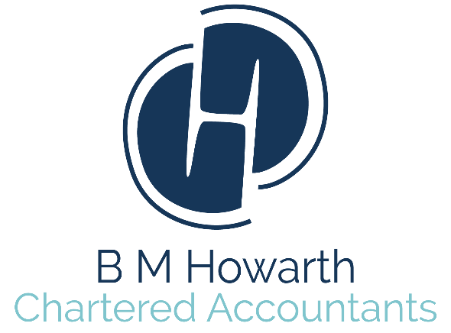

Tax Apprenticeship Vacancy
B M Howarth Ltd

Not wanting to go to University? Wanting to earn while you learn and study for a Level 4 Higher Apprenticeship equivalent to a Foundation Degree?

B M Howarth Ltd is an expanding Accountancy firm with offices in Halifax, Wakefield and Leeds. The firm offers accountancy, taxation, business advisory and support services to a wide range of businesses and individuals.

We are looking for an Apprentice to join us in September 2020 working from our Halifax office. You will be studying for the Level 4 ATT Higher Apprenticeship. The job will require excellent numeracy and communication skills, a high level of accuracy and the ability to meet strict deadlines. You must possess a good work ethic and work well as part of a team. A desire to learn and gain experience is also a key attribute to the position.

Job Description:

Working in the Tax Department has a range of requirements, giving variety to an Apprentice’s everyday work life. General day to day tasks include the following;

- Assisting in the completion of Self-Assessment Tax Returns
- Assisting in the preparation of forms P11d
- Dealing with telephone and email queries from clients
- Dealing with HMRC by telephone and correspondence
- Reviewing tax codes
- Preparing tax computations
- Assistance with tax planning
- Liaising with the Accounts team to ensure a high standard of client service

The Apprenticeship is a two year course which will allow you to study whilst you are working. This entails attending college days in Leeds with Kaplan to work towards the ATT qualification. The qualification consists of three written exams that are sat in May/November as well as three computer based exams that can be sat at any time during the qualification. Full support will be given by colleagues who have achieved the qualification.

Benefits of the position:

- Choosing this Apprenticeship avoids the high costs of attending university and gives you the opportunity to earn whilst you learn
- Achieve a Level 4 qualification equivalent to a Foundation Degree
- Develop your communication skills by interacting with colleagues and clients
- Free car parking facilities for all employees

Starting Salary: Minimum Wage for age (not Apprenticeship Rate)
Experience Required: None
Education Required: A Level or equivalent
Job Type: Permanent
Job Status: Full Time

If you wish to apply for the vacancy please email Lisa.Habergham@bm-howarth.co.uk expressing your interest and attach your CV.

